**SALES OF E-COMMERCE PLATFORM (GOLD)**

**1)Explore all countries our customers come from.**

SELECT DISTINCT COUNTRY

FROM DIM_CUSTOMERS;

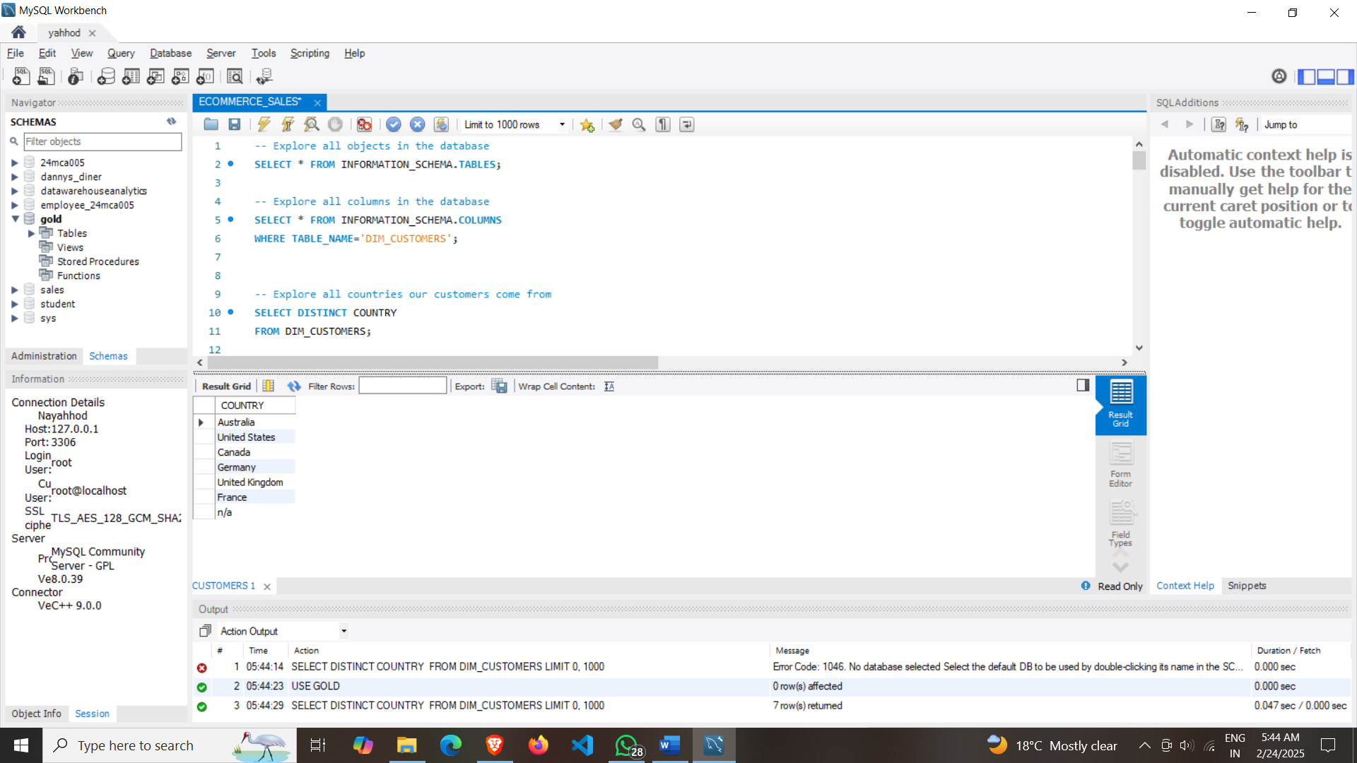

**2)** **Explore all categories of products.**

SELECT DISTINCT CATEGORY FROM DIM_PRODUCTS;

OR

SELECT

DISTINCT CATEGORY ,SUBCATEGORY,

PRODUCT_NAME FROM DIM_PRODUCTS

ORDER BY 1,2,3;

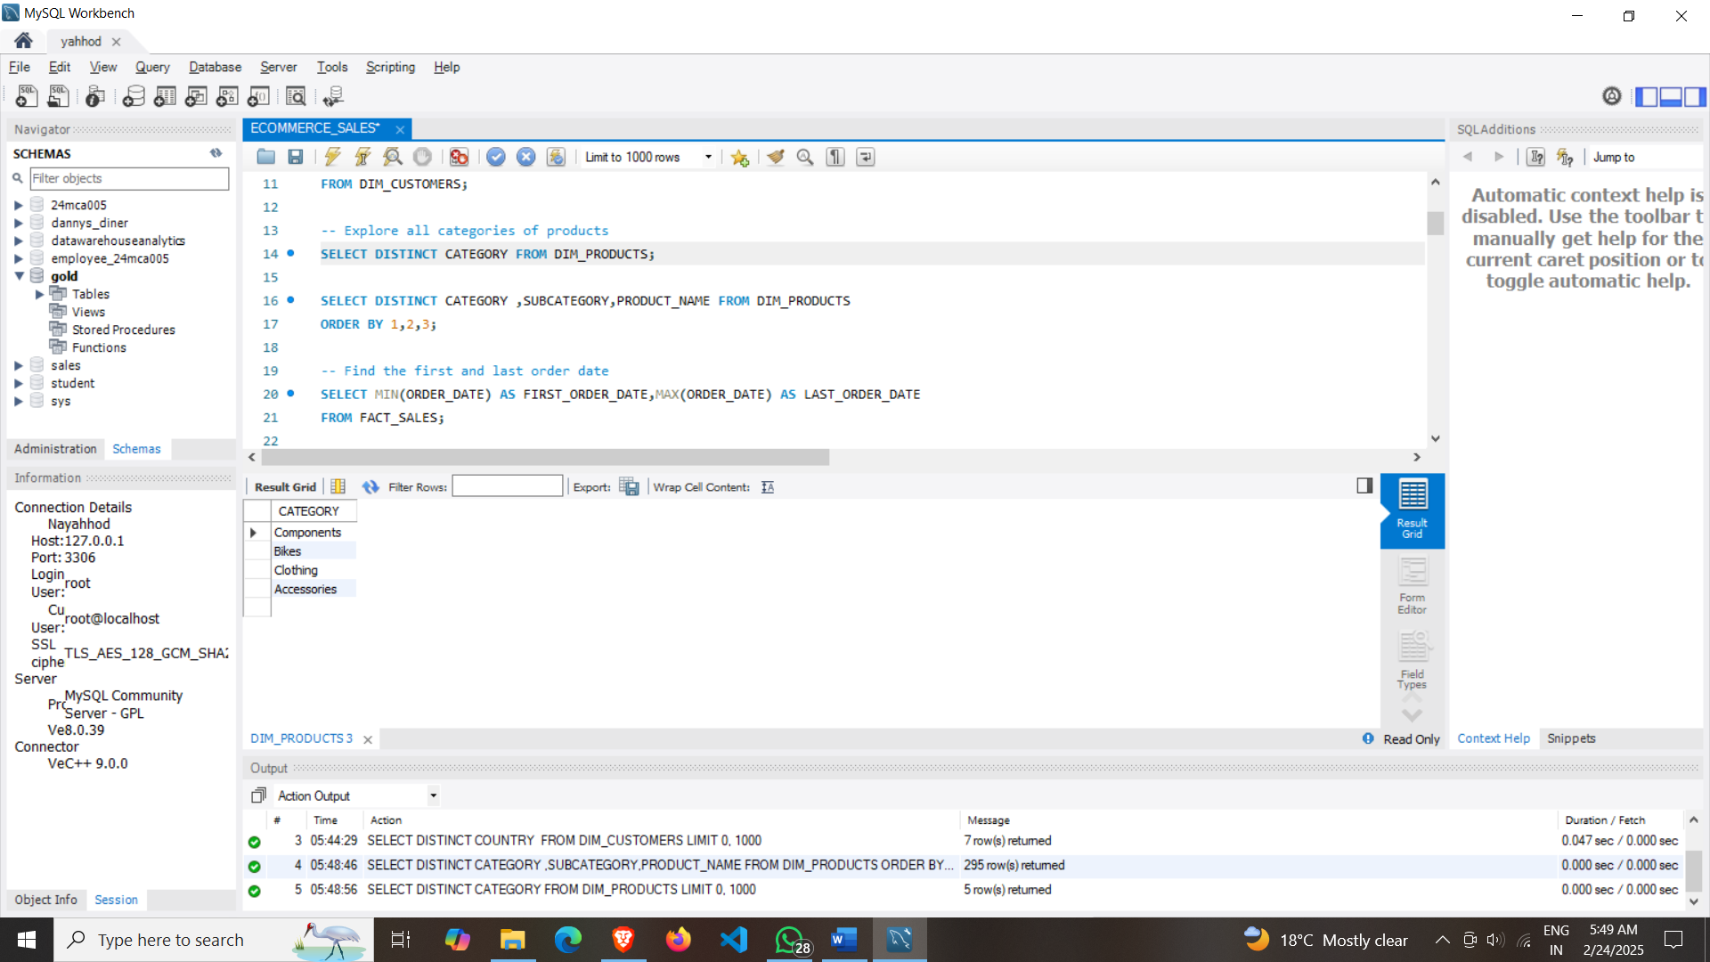

**3)** **Find the first and last order date.**

SELECT

MIN(ORDER_DATE) AS FIRST_ORDER_DATE,

MAX(ORDER_DATE) AS LAST_ORDER_DATE

FROM FACT_SALES;

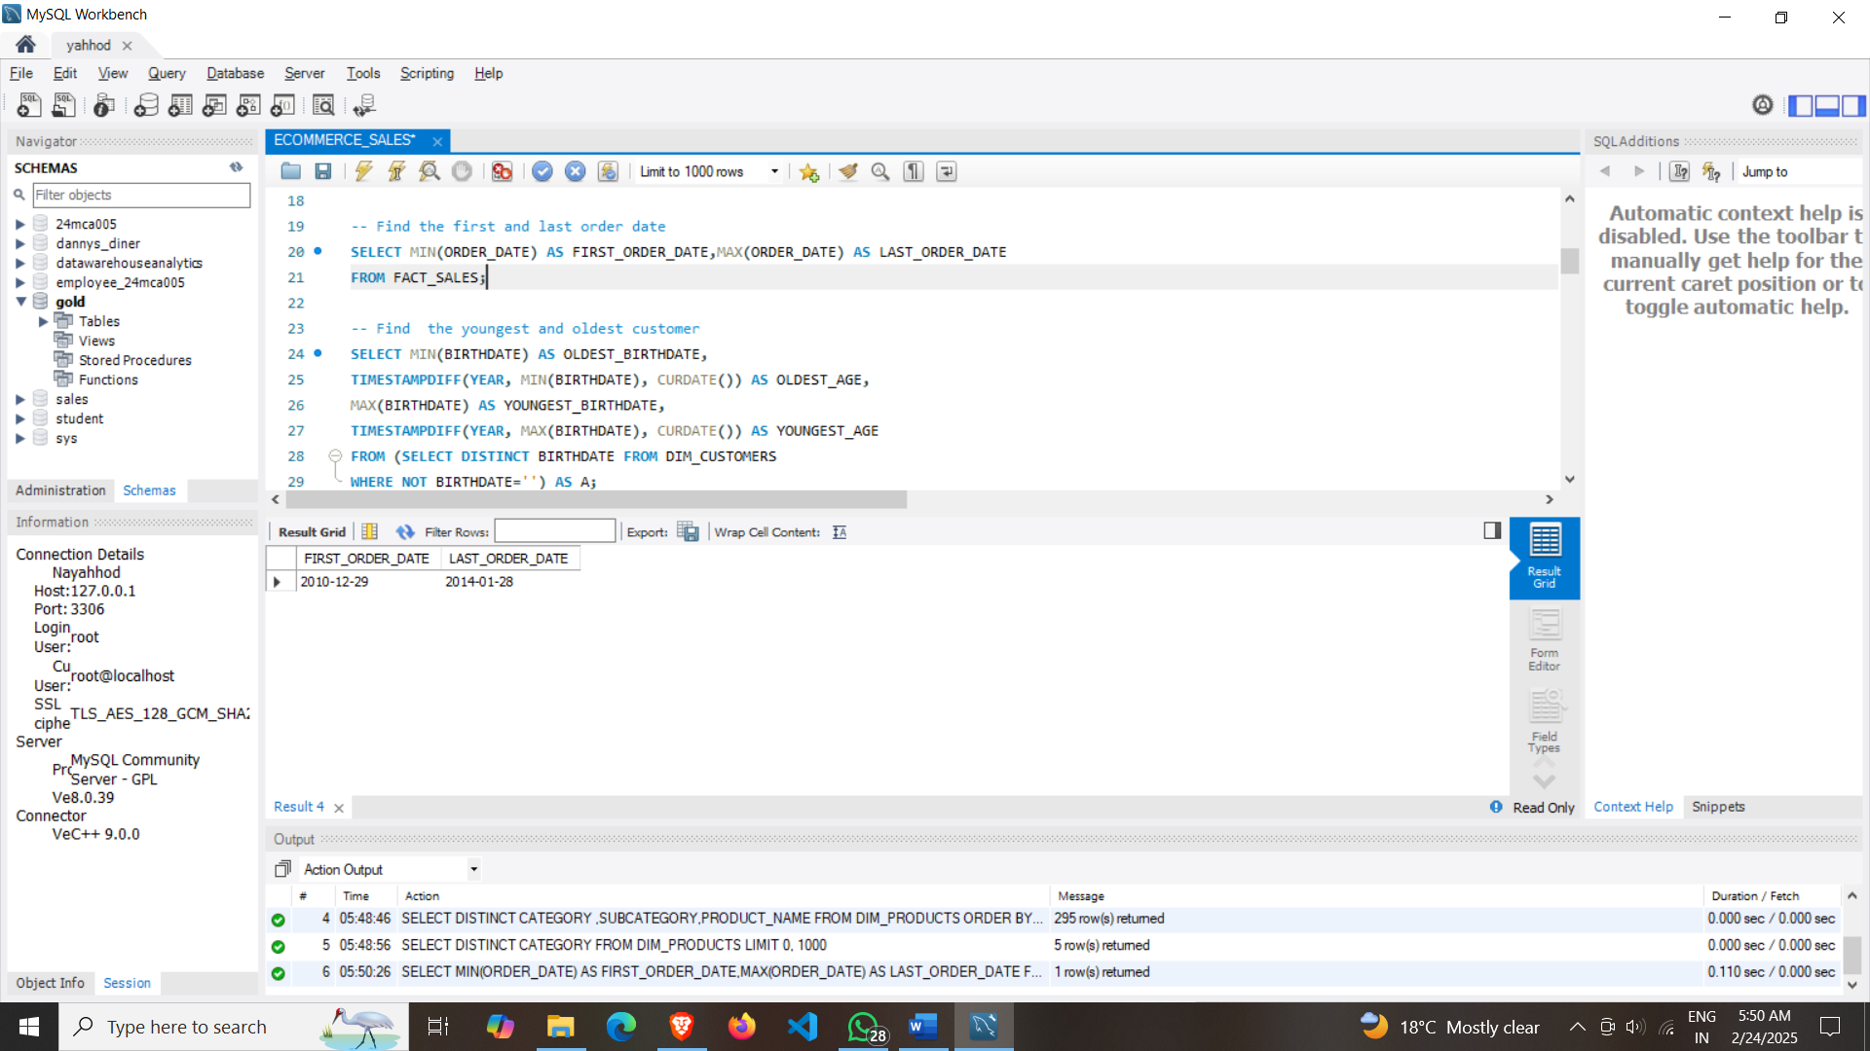

**4)** **Find the youngest and oldest customer.**

SELECT

MIN(BIRTHDATE) AS OLDEST_BIRTHDATE,

TIMESTAMPDIFF(YEAR, MIN(BIRTHDATE), CURDATE()) AS OLDEST_AGE,

MAX(BIRTHDATE) AS YOUNGEST_BIRTHDATE,

TIMESTAMPDIFF(YEAR, MAX(BIRTHDATE), CURDATE()) AS YOUNGEST_AGE

FROM (SELECT DISTINCT BIRTHDATE FROM DIM_CUSTOMERS

WHERE NOT BIRTHDATE='') AS A;

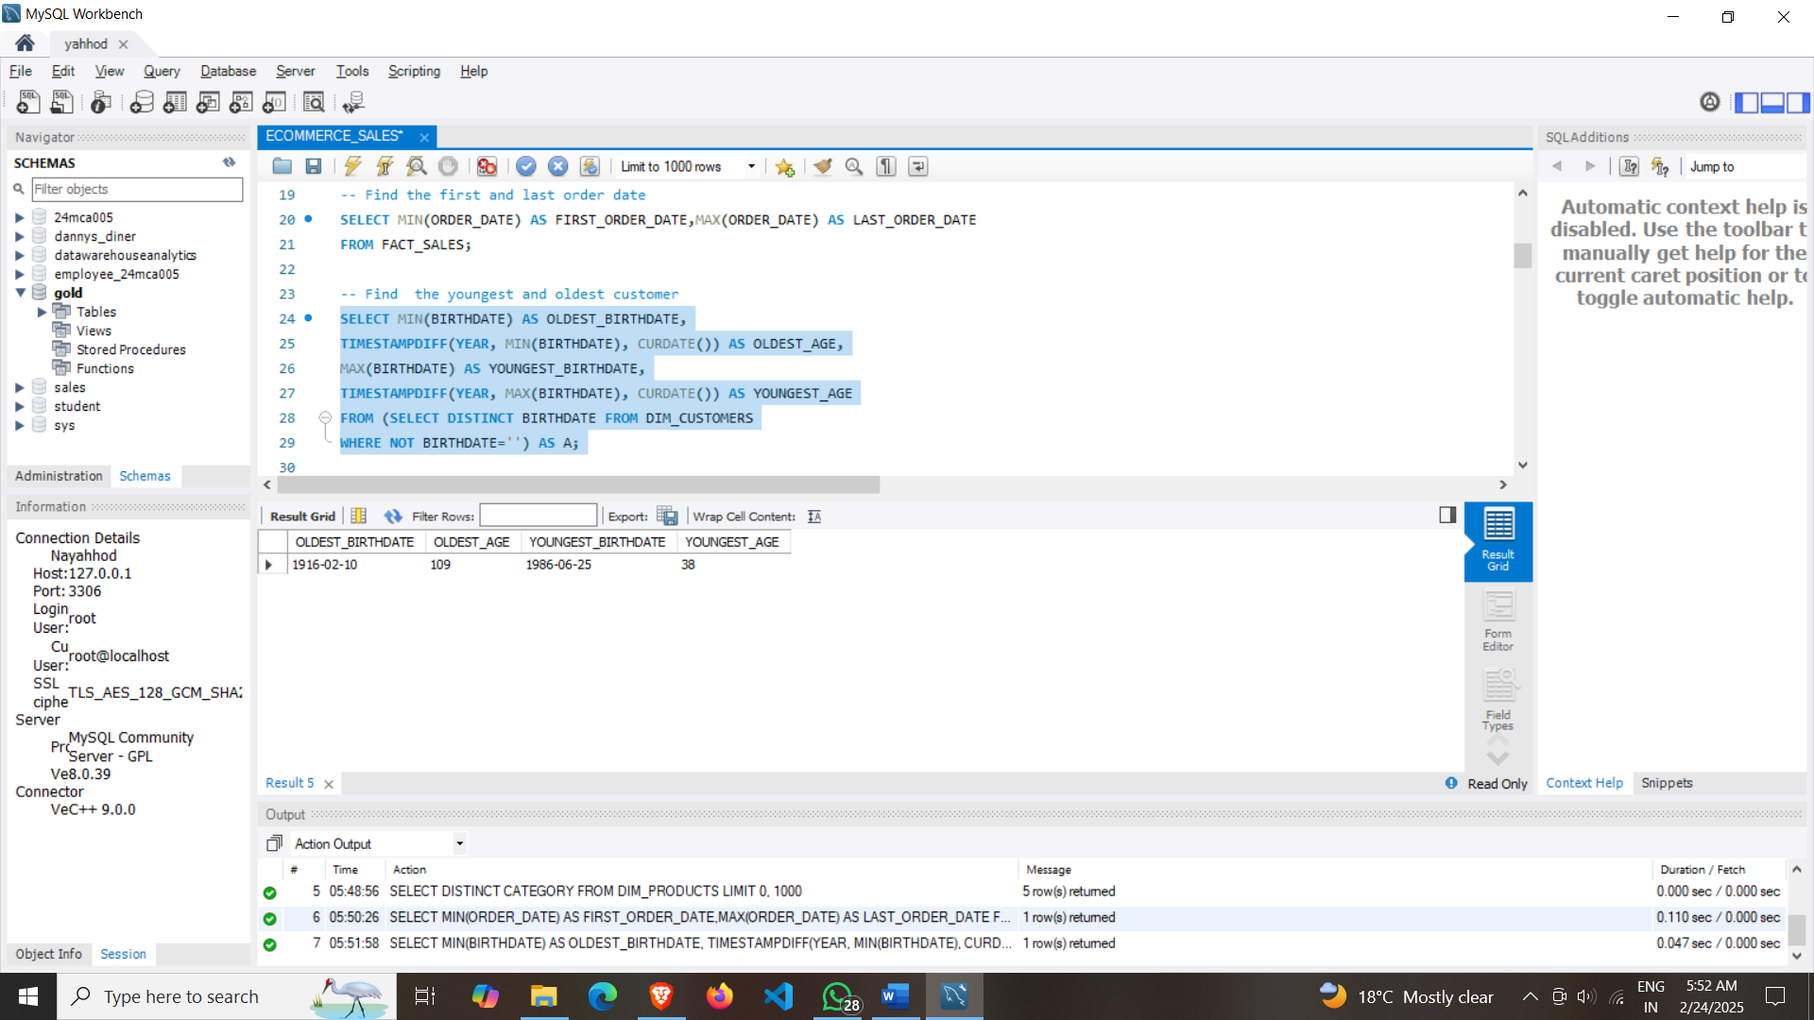

**Business Question**

**5) GENERATE A REPORT THAT SHOWS ALL KEY METRICS OF THE BUSINESS.**

SELECT 'TOTAL_SALES' AS MEASURE_NAME, SUM(SALES_AMOUNT) AS MEASURE_VALUES FROM FACT_SALES

UNION ALL

SELECT 'TOTAL_QUANTITY' AS MEASURE_NAME,SUM(QUANTITY) AS MEASURE_VALUES FROM FACT_SALES

UNION ALL

SELECT 'AVERAGE_SELLING_PRICE' AS MEASURE_NAME,ROUND(AVG(PRICE),0) AS MEASURE_VALUES FROM FACT_SALES

UNION ALL

SELECT 'TOTAL_ORDERS' AS MEASURE_NAME,COUNT(DISTINCT ORDER_NUMBER) AS MEASURE_VALUES FROM FACT_SALES

UNION ALL

SELECT 'TOTAL_PRODUCTS' AS MEASURE_NAME,COUNT(DISTINCT PRODUCT_NAME) AS MEASURE_VALUES FROM DIM_PRODUCTS

UNION ALL

SELECT 'TOTAL_REGISTER_CUSTOMERS' AS MEASURE_NAME,COUNT(CUSTOMER_KEY) AS MEASURE_VALUES FROM DIM_CUSTOMERS

UNION ALL

SELECT 'TOTAL_ORDER_CUSTOMERS' AS MEASURE_NAME,COUNT(DISTINCT CUSTOMER_KEY) AS MEASURE_VALUES FROM FACT_SALES;

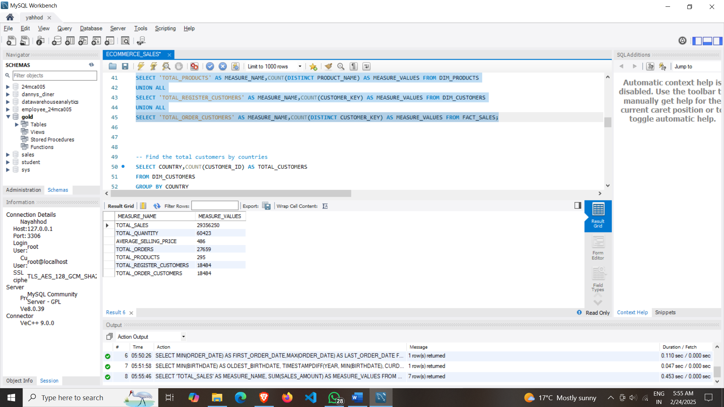

**6)** **Find the total customers by countries.**

SELECT

COUNTRY,

COUNT(CUSTOMER_ID) AS TOTAL_CUSTOMERS

FROM DIM_CUSTOMERS

GROUP BY COUNTRY

ORDER BY 2 DESC;

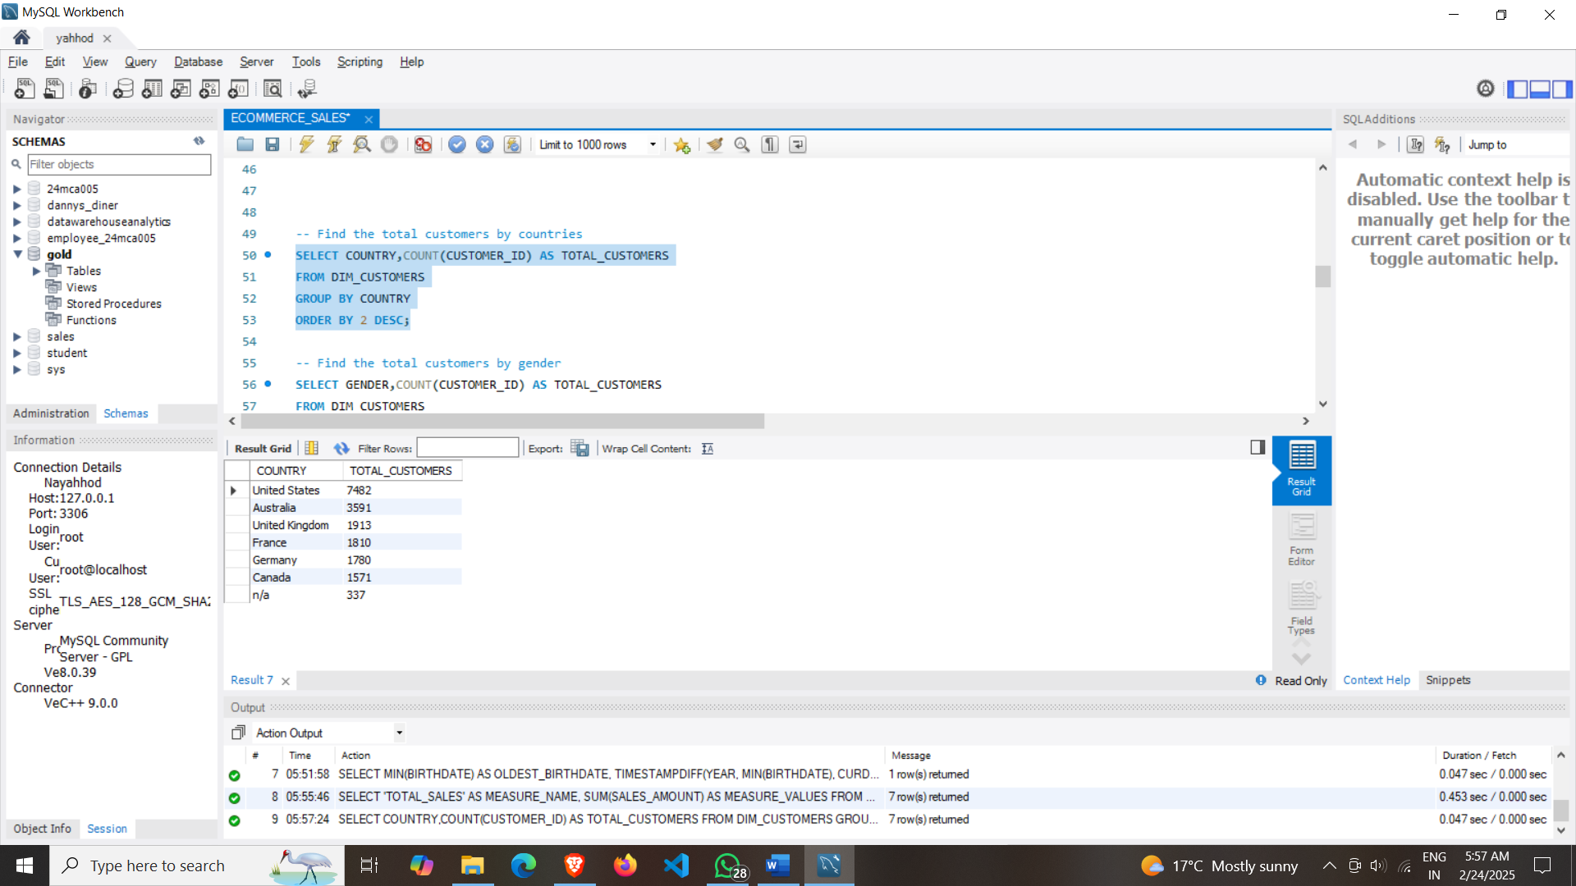

**7)** **Find the total customers by gender.**

SELECT

GENDER,

COUNT(CUSTOMER_ID) AS TOTAL_CUSTOMERS

FROM DIM_CUSTOMERS

GROUP BY GENDER;

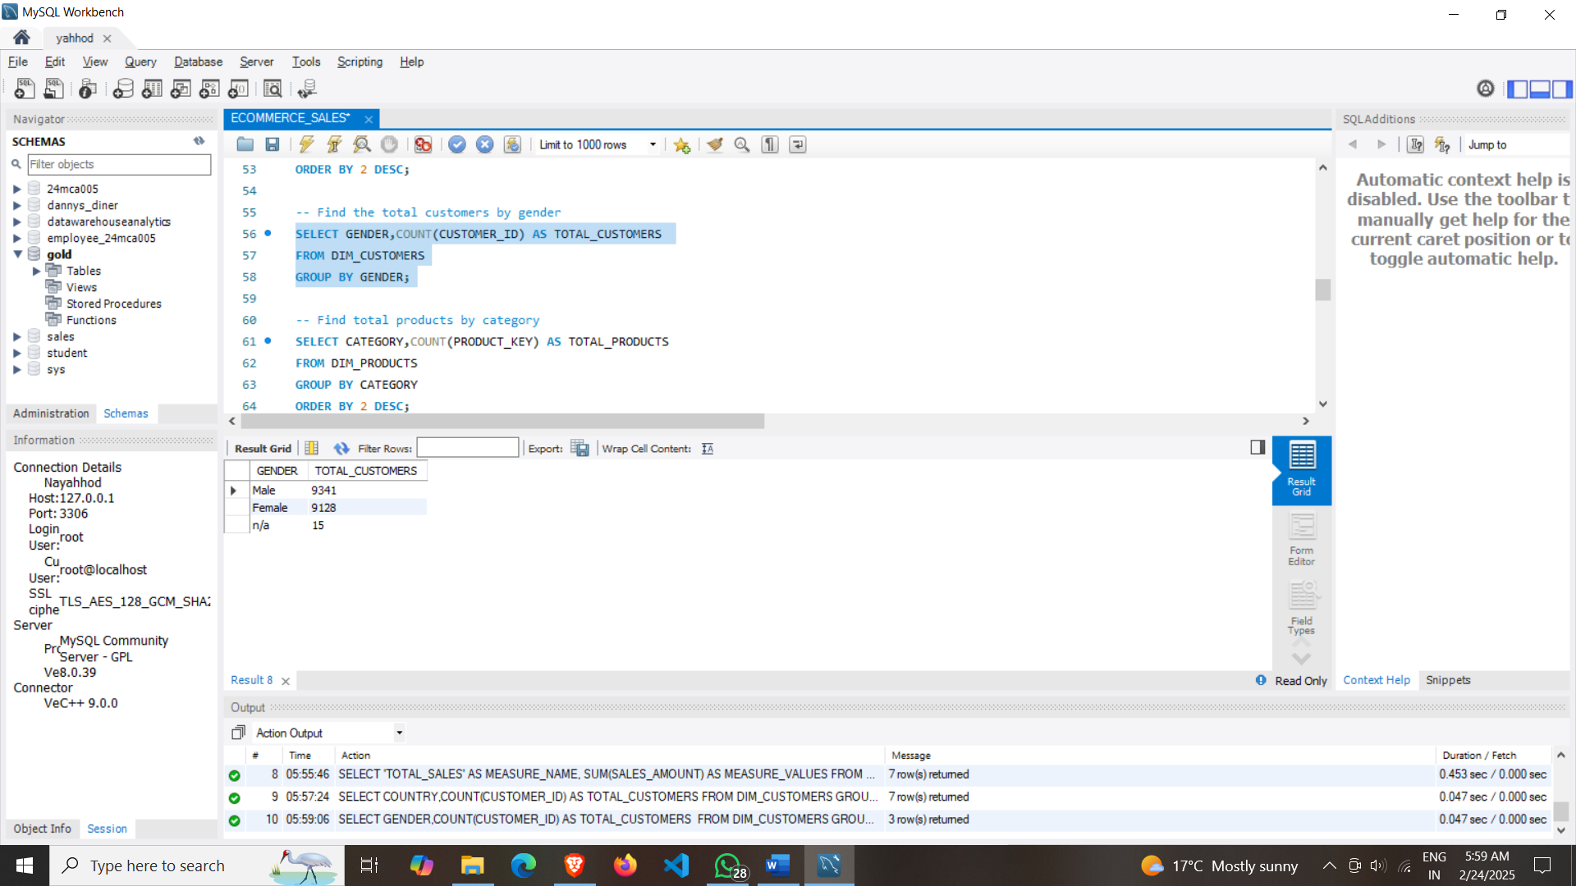

**8)** **Find total products by category.**

SELECT

CATEGORY,

COUNT(PRODUCT_KEY) AS TOTAL_PRODUCTS

FROM DIM_PRODUCTS

GROUP BY CATEGORY

ORDER BY 2 DESC;

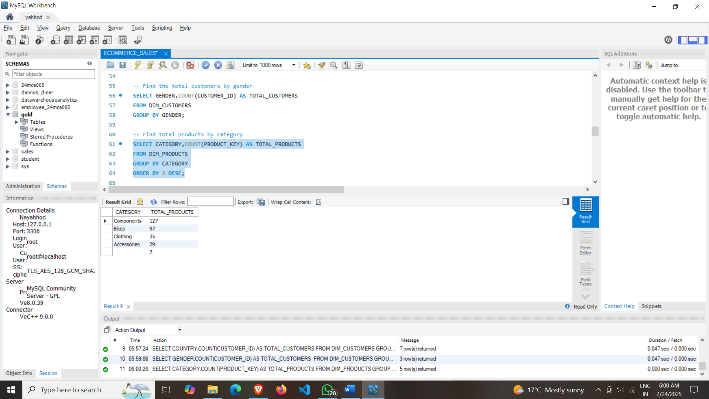

**9)** **Find average cost in each category.**

SELECT

CATEGORY,

AVG(COST) AS AVG_COST

FROM DIM_PRODUCTS

GROUP BY CATEGORY

ORDER BY 2 DESC;

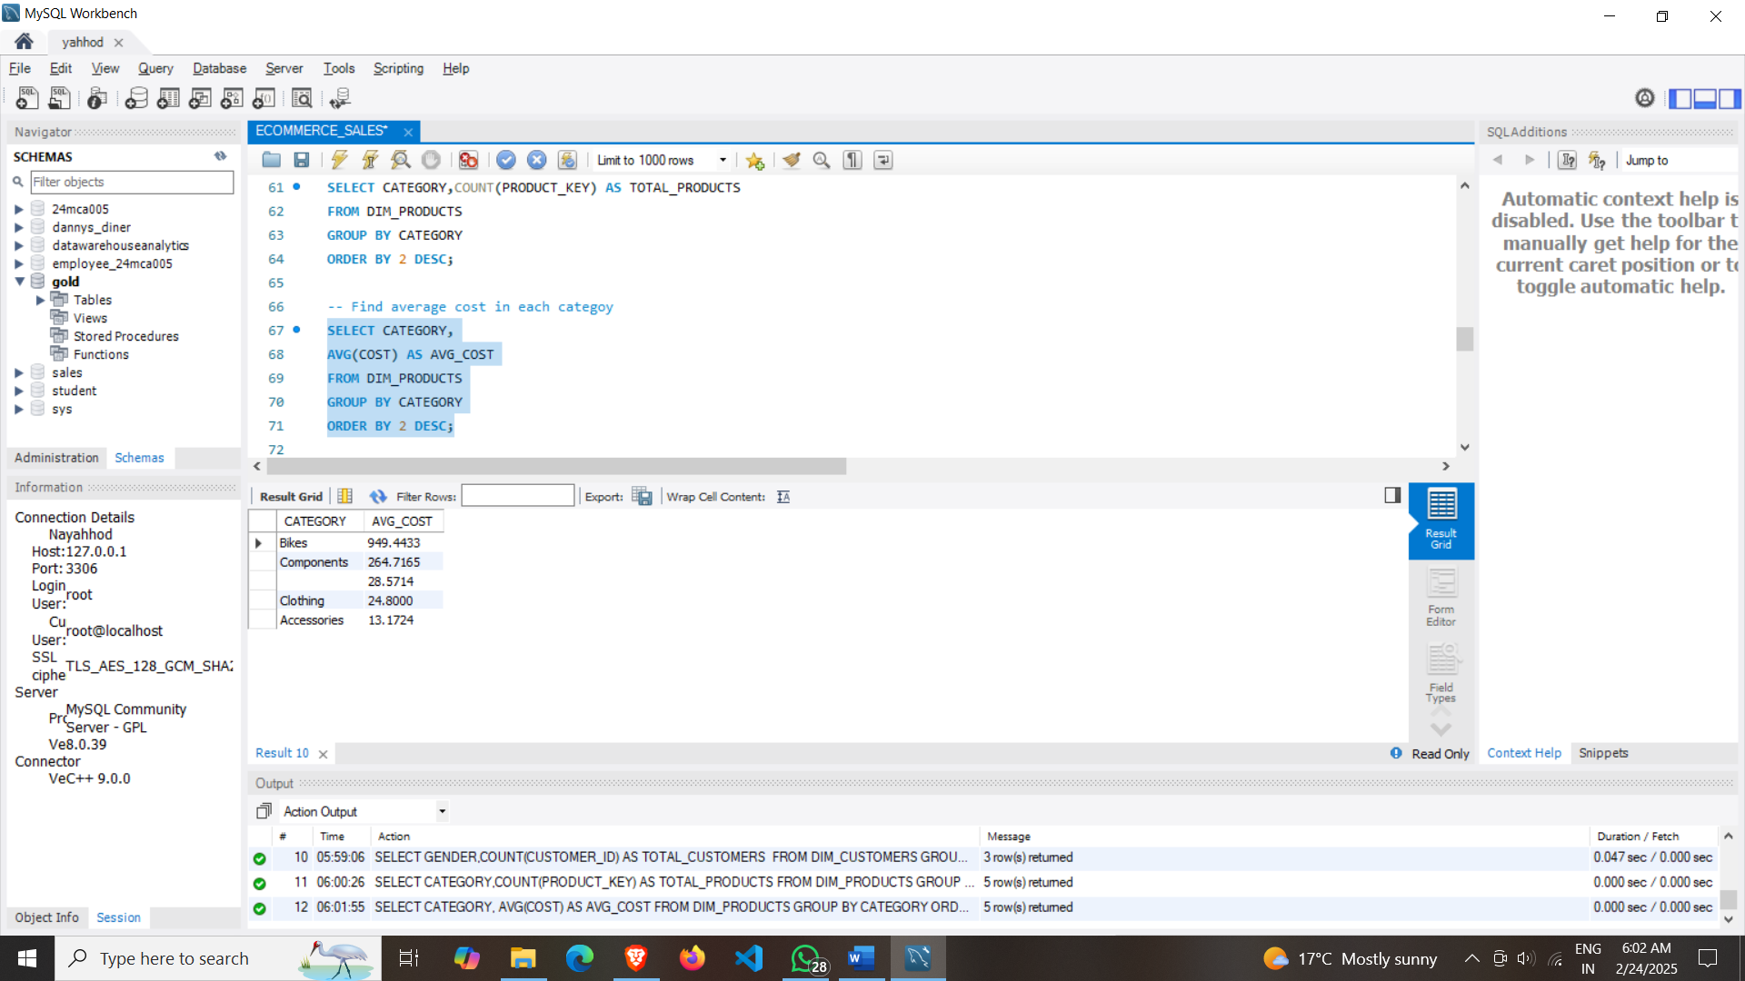

**10)** **Find total revenue generated for each category.**

SELECT

P.CATEGORY,

SUM(F.SALES_AMOUNT) AS TOTAL_REVENUE

FROM FACT_SALES AS F LEFT JOIN DIM_PRODUCTS AS P

ON F.PRODUCT_KEY=P.PRODUCT_KEY

GROUP BY P.CATEGORY

ORDER BY 2 DESC;

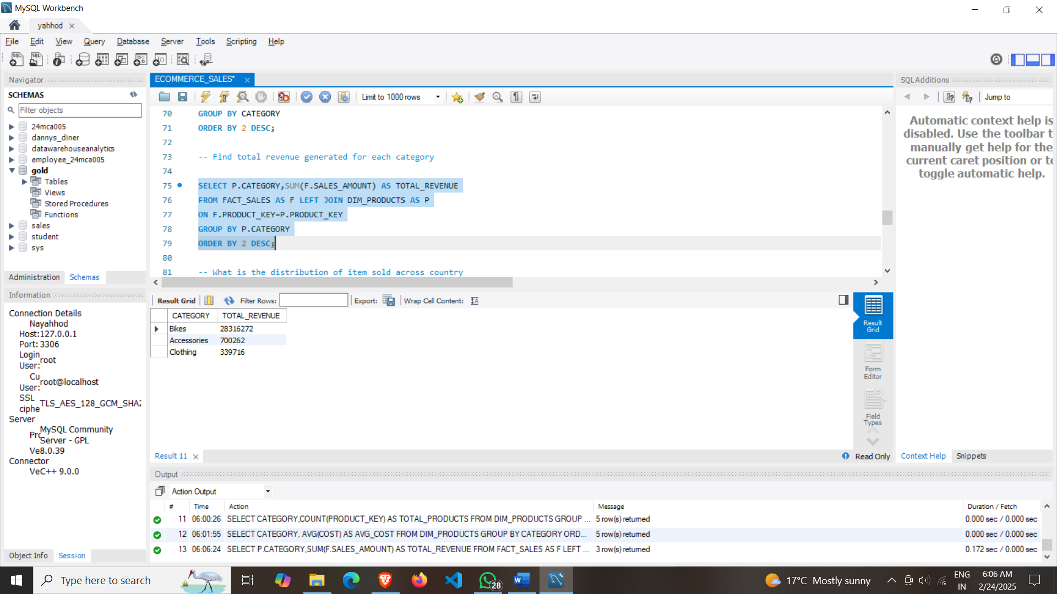

**11)** **What is the distribution of item sold across country.**

SELECT

C.COUNTRY,

SUM(F.QUANTITY) AS TOTAL_SOLD_ITEMS

FROM FACT_SALES AS F LEFT JOIN DIM_CUSTOMERS AS C

ON F.CUSTOMER_KEY=C.CUSTOMER_KEY

GROUP BY C.COUNTRY

ORDER BY 2 DESC;

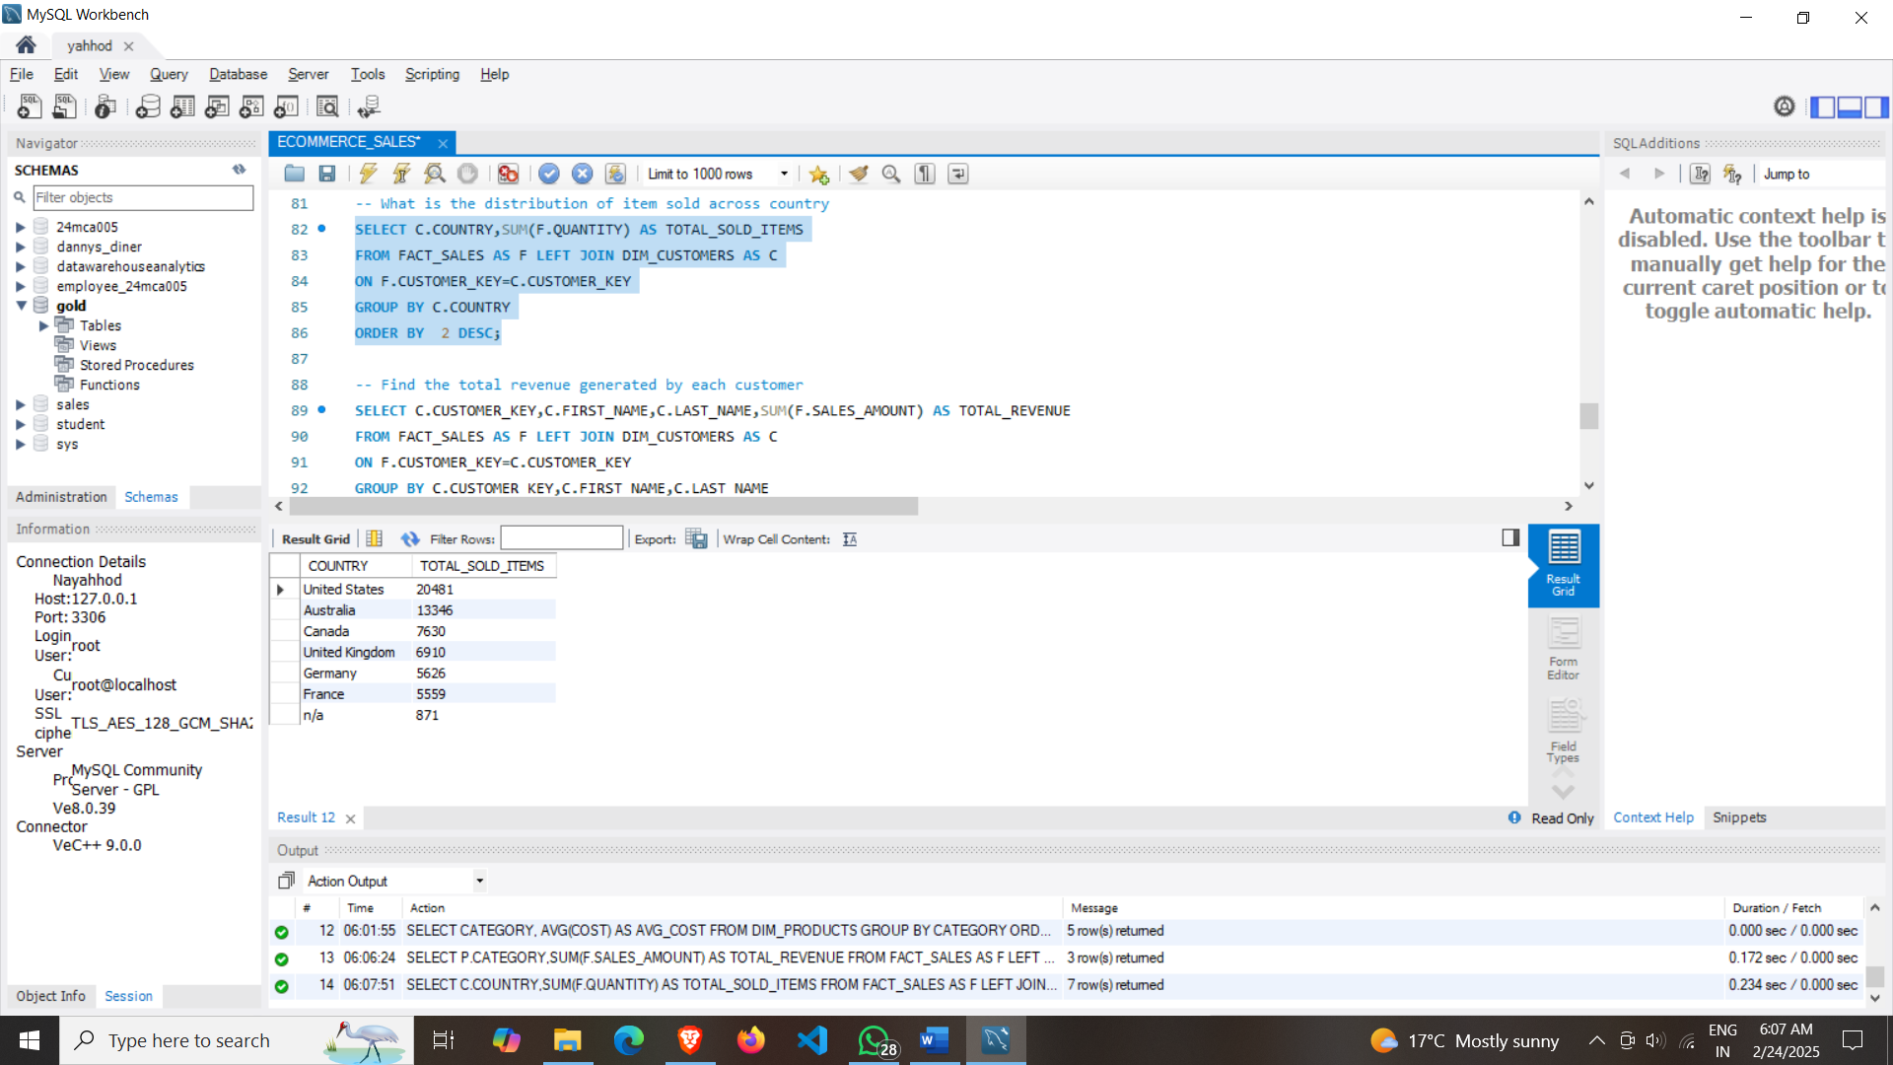

**12)** **Find the total revenue generated by each customer.**

SELECT

C.CUSTOMER_KEY,

C.FIRST_NAME,

C.LAST_NAME,

SUM(F.SALES_AMOUNT) AS TOTAL_REVENUE

FROM FACT_SALES AS F LEFT JOIN DIM_CUSTOMERS AS C

ON F.CUSTOMER_KEY=C.CUSTOMER_KEY

GROUP BY C.CUSTOMER_KEY,C.FIRST_NAME,C.LAST_NAME

ORDER BY 4 DESC;

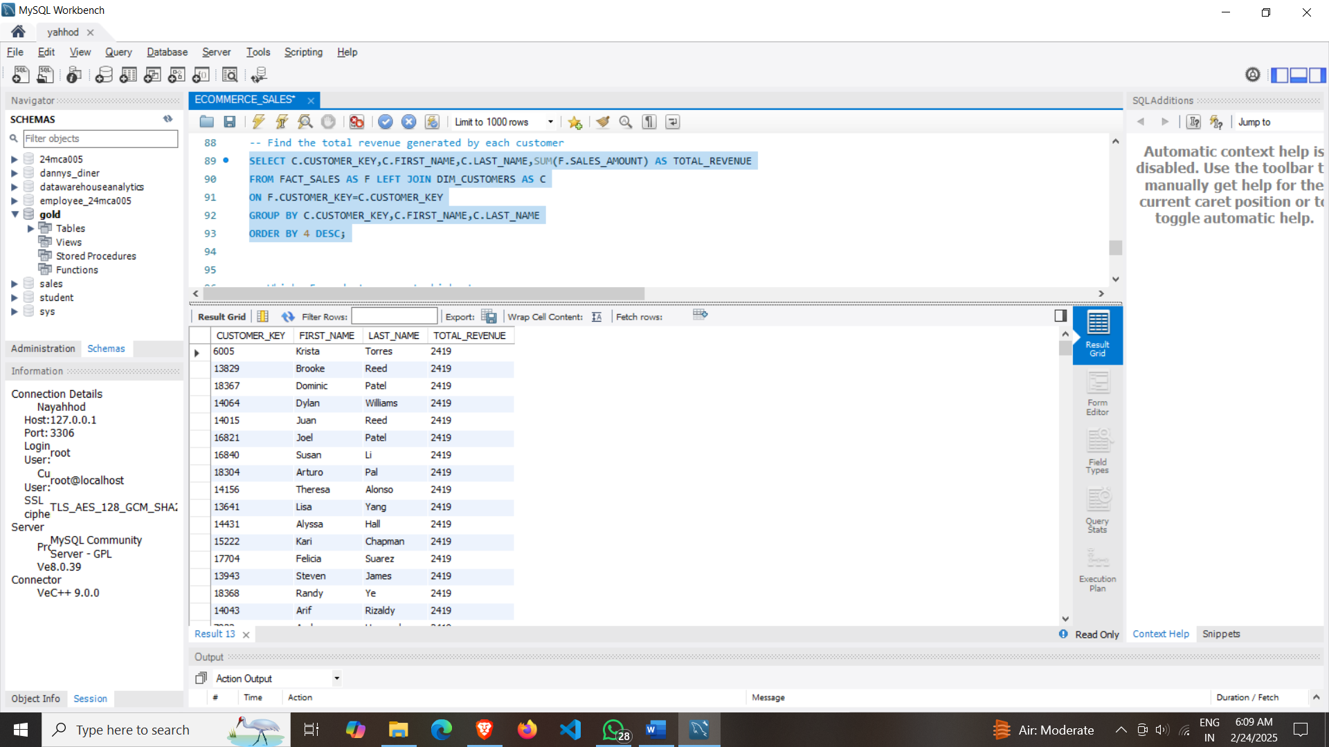

**13) Which 5 products generate highest revenue.**

SELECT

P.PRODUCT_NAME ,

SUM(F.SALES_AMOUNT) AS TOTAL_REVENUE

FROM FACT_SALES AS F LEFT JOIN DIM_PRODUCTS AS P ON F.PRODUCT_KEY=P.PRODUCT_KEY

GROUP BY P.PRODUCT_NAME

ORDER BY 2 DESC

LIMIT 5;

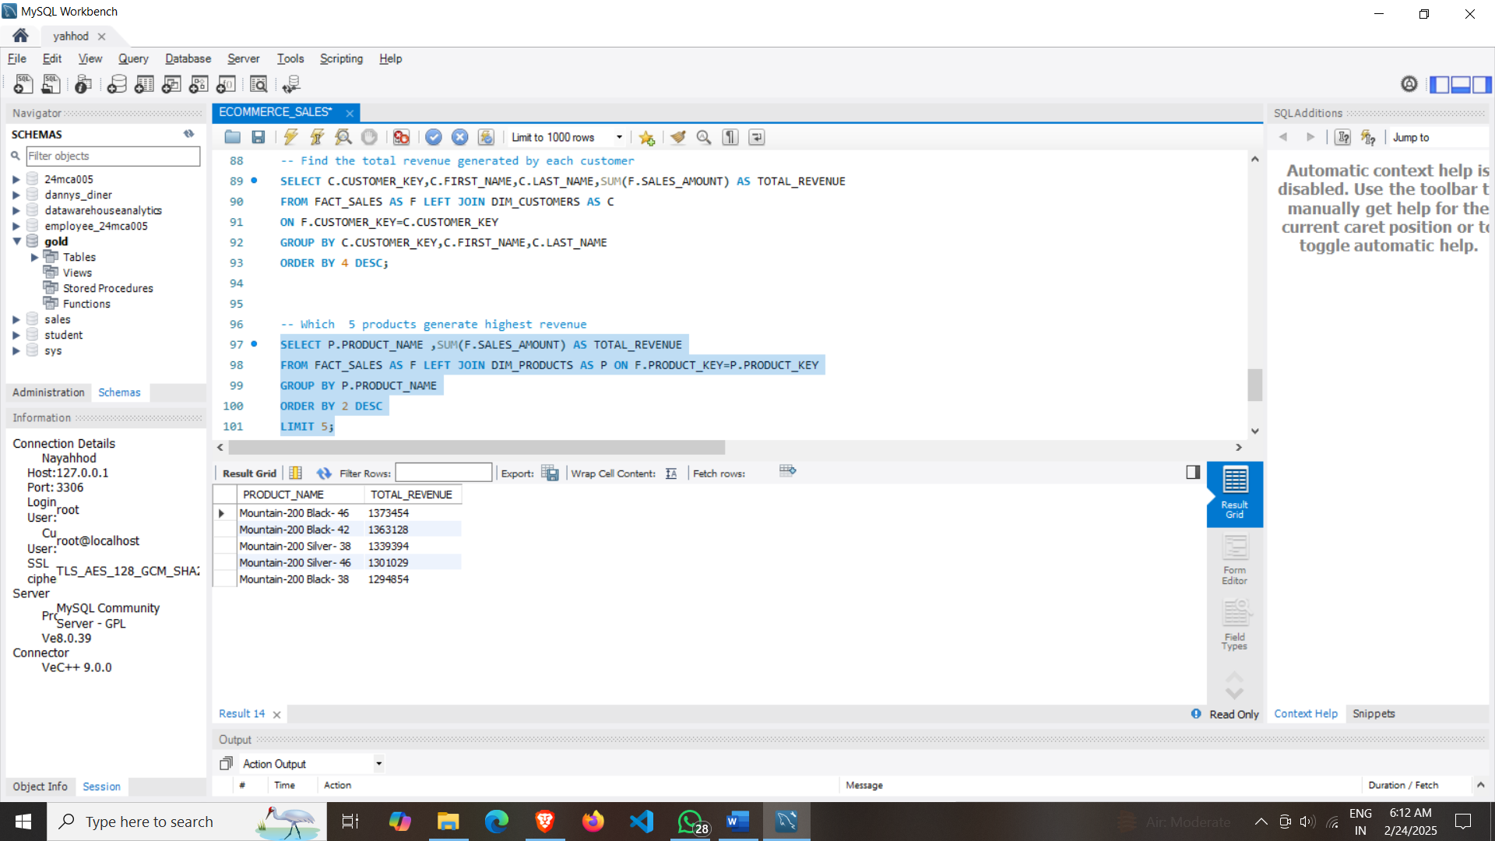

**14)** **Which 5 products generate worst revenue.**

SELECT *

FROM

(SELECT

P.PRODUCT_NAME ,

SUM(F.SALES_AMOUNT) AS TOTAL_REVENUE,

RANK() OVER(ORDER BY SUM(F.SALES_AMOUNT)) AS PRODUCT_RANK

FROM FACT_SALES AS F LEFT JOIN DIM_PRODUCTS AS P ON F.PRODUCT_KEY=P.PRODUCT_KEY

GROUP BY P.PRODUCT_NAME) AS A

WHERE PRODUCT_RANK<=5;

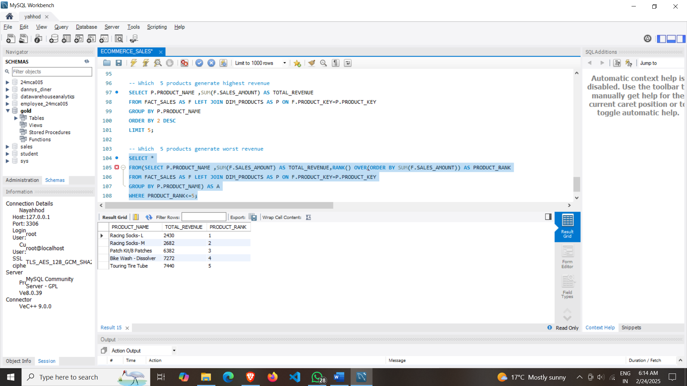

GitHub Repo: https://github.com/Jaypatwal102/E_COMMERCE_SALES.git

© 2023 [Jay Patwal](http://www.linkedin.com/in/jay-patwal-03046322b)